

**SL-3003 – Web Engineering Lab**

**Lab 7:** DOM Manipulation

**Lab Coordinator:**

Ms. Zoya Sumbul Zaheer

**Lab Instructors:**

Ms. Zoya Mahboob, Ms. Noor Ul Ain,

Mr. Muhammad Wasif Ali

**1. Introduction to the DOM**

The **Document Object Model (DOM)** is a programming interface for web documents. It represents the structure of a document as a tree of objects, allowing programming languages to manipulate the content, structure, and style of web pages.

**Key Concepts:**

* **Nodes**: Each part of the document (elements, attributes, text) is a node in the DOM tree.
* **Elements**: HTML elements (like <div>, <p>, etc.) are represented as nodes.

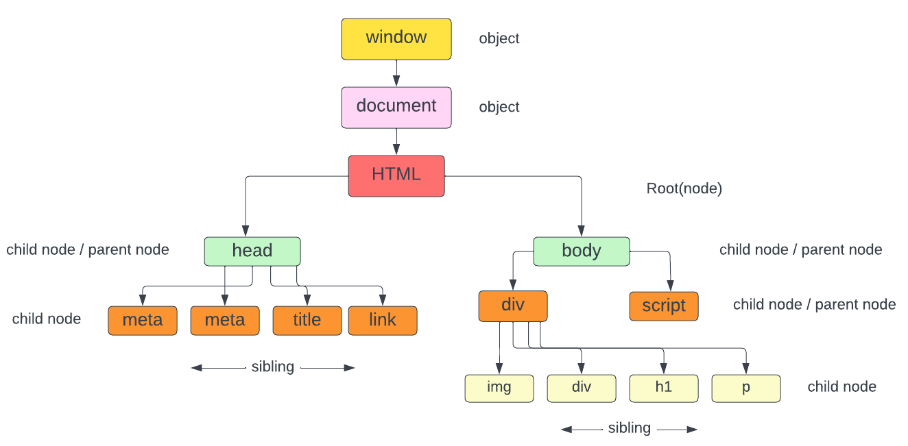

**jQuery** is a popular JavaScript library that simplifies many common DOM manipulation tasks, offering a more concise and readable syntax.

**Adding jQuery to Your Project**

To use jQuery in your project, include the jQuery library either by downloading it or using a CDN (Content Delivery Network).

**Using a CDN:**

***<script src="https://ajax.googleapis.com/ajax/libs/jquery/3.7.1/jquery.min.js"></script>***

**2. Selecting Elements**

To manipulate elements, we first need to select them. Here are the most common methods:

**Vanilla JavaScript:**

* **document.getElementById(id)**: Selects an element by its ID.
* **document.getElementsByClassName(className)**: Selects elements by their class name.
* **document.getElementsByTagName(tagName)**: Selects elements by their tag name.
* **document.querySelector(selector)**: Selects the first element that matches a CSS selector.
* **document.querySelectorAll(selector)**: Selects all elements that match a CSS selector.

**jQuery Alternative:**

* **$('#id')**: Selects an element by its ID.
* **$('.className')**: Selects elements by their class name.
* **$('tagName')**: Selects elements by their tag name.
* **$(selector)**: Selects elements using a CSS selector.

**EXAMPLE:**

**Vanilla JavaScript**

const heading = document.getElementById('myHeading');

const paragraphs = document.getElementsByClassName('myParagraphs');

**jQuery**

const headingJQ = $('#myHeading');

const paragraphsJQ = $('.myParagraphs');

**3. Modifying Elements**

Once an element is selected, you can modify its properties.

**Vanilla JavaScript:**

* **innerHTML**: Get or set the HTML content of an element.
* **textContent**: Get or set the text content of an element.
* **style**: Modify CSS styles directly.
* **className**: Get or set the class name(s).

**jQuery Alternative:**

* **.html()**: Get or set the HTML content of an element.
* **.text()**: Get or set the text content of an element.
* **.css()**: Get or set the CSS properties of an element.
* **.addClass() / .removeClass()**: Add or remove class(es) to/from an element.

**Example:**

**Vanilla JavaScript**

***const heading = document.getElementById('myHeading');***

***heading.textContent = 'New Heading Text';***

***heading.style.color = 'blue';***

**jQuery**

***$('#myHeading').text('New Heading Text').css('color', 'blue');***

**4. Creating and Inserting Elements**

You can create new elements and insert them into the DOM.

**Methods:**

**Vanilla JavaScript:**

* **document.createElement(tagName)**: Creates a new element.
* **parentElement.appendChild(child)**: Appends a child element to a parent.
* **parentElement.insertBefore(newElement, referenceElement)**: Inserts a new element before a reference element.

**jQuery Alternative:**

* **$('<tagName>')**: Creates a new element.
* **.append()**: Appends a child element to the parent.
* **.before() / .after()**: Inserts a new element before or after another element.

**Example:**

**Vanilla JavaScript**

***const newDiv = document.createElement('div');***

***newDiv.textContent = 'This is a new div.';***

***document.body.appendChild(newDiv);***

**jQuery**

***$('<div>This is a new div.</div>').appendTo('body');***

**5. Removing Elements**

To remove an element from the DOM, you can use the following methods:

**Methods:**

**Vanilla JavaScript:**

* **element.remove()**: Removes the element itself.
* **parentElement.removeChild(child)**: Removes a child element from the parent.

**jQuery Alternative:**

* **.remove()**: Removes the selected element(s) from the DOM.
* **.empty()**: Removes the content of the selected element(s), but keeps the element itself.

**Example:**

**Vanilla JavaScript**

***const paragraph = document.getElementById('myParagraph');***

***paragraph.remove();***

**jQuery**

***$('#myParagraph').remove();***

## ****6. Event Handling****

JavaScript allows you to respond to user interactions through events. You can add event listeners to elements.

### ****Methods:****

**Vanilla JavaScript:**

* **element.addEventListener(event, function)**: Attaches an event handler to an element.

**jQuery Alternative:**

* **.on(event, function)**: Binds an event handler to an element.

**Example:**

**Vanilla JavaScript**

***const button = document.getElementById('myButton');***

***button.addEventListener('click', function() {***

***alert('Button clicked!');***

***});***

**jQuery**

***$('#myButton').on('click', function() {***

***alert('Button clicked!');***

***});*Toggle Example(Vanilla JavaScript):**

<!DOCTYPE html>

<html lang="en">

<head>

    <meta charset="UTF-8">

    <meta name="viewport" content="width=device-width, initial-scale=1.0">

    <title>Toggle Example</title>

</head>

<body>

    <h1>Toggle Example</h1>

    <button id="toggleBtn">Toggle</button>

    <div id="content">HELLO WORLD!</div>

    <script>

        const content = document.getElementById('content');

        document.getElementById('toggleBtn').addEventListener('click', function() {

            content.style.display = content.style.display === 'none' ? 'block' : 'none';

        });

    </script>

</body>

</html>

**Toggle Example(JQuery):**

$('#toggleBtn').on('click', function() {

$('#content').toggle();

});

**Output:**

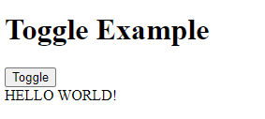

**Toggled to**

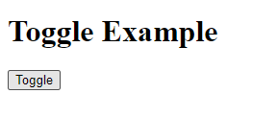

**For a more detailed study on the DOM, visit the following link:**

<https://www.freecodecamp.org/news/the-javascript-dom-manipulation-handbook/>